**PowerBI Installation Assignment**

1. Install Power BI Desktop and share the final screenshot of the report view page which appears when power desktop starts. 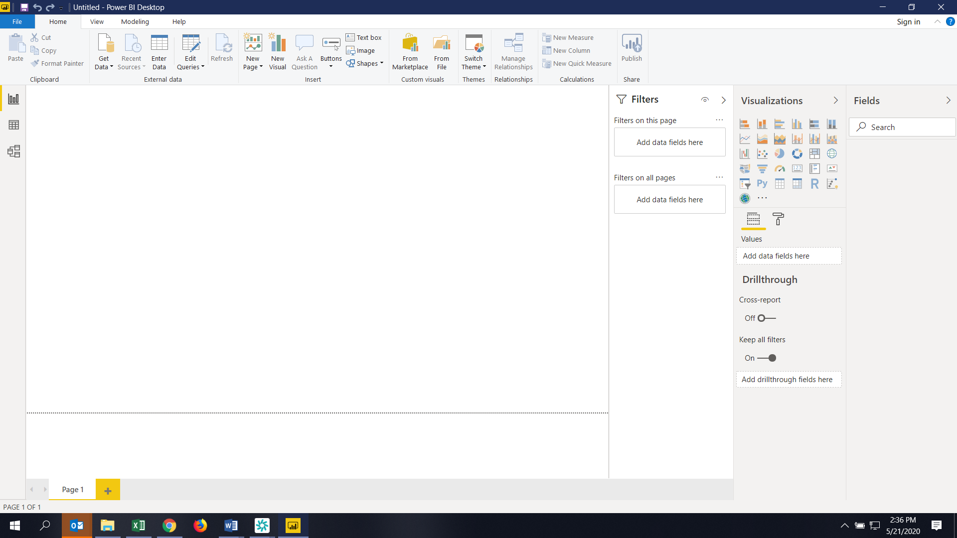
2. Prepare a document and with the following screenshot
   1. Report View 
   2. Data View 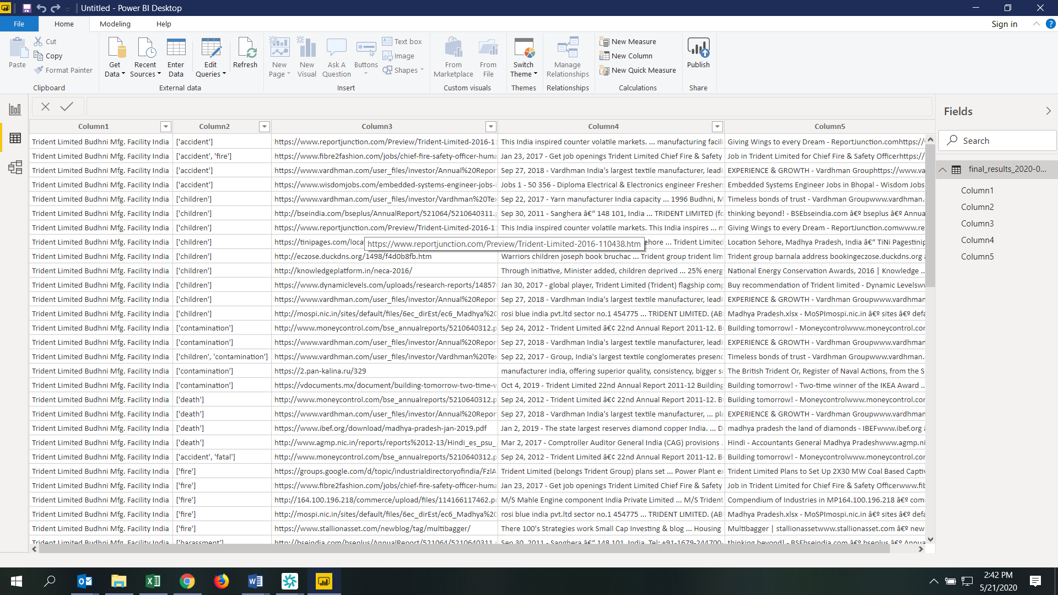
   3. Model View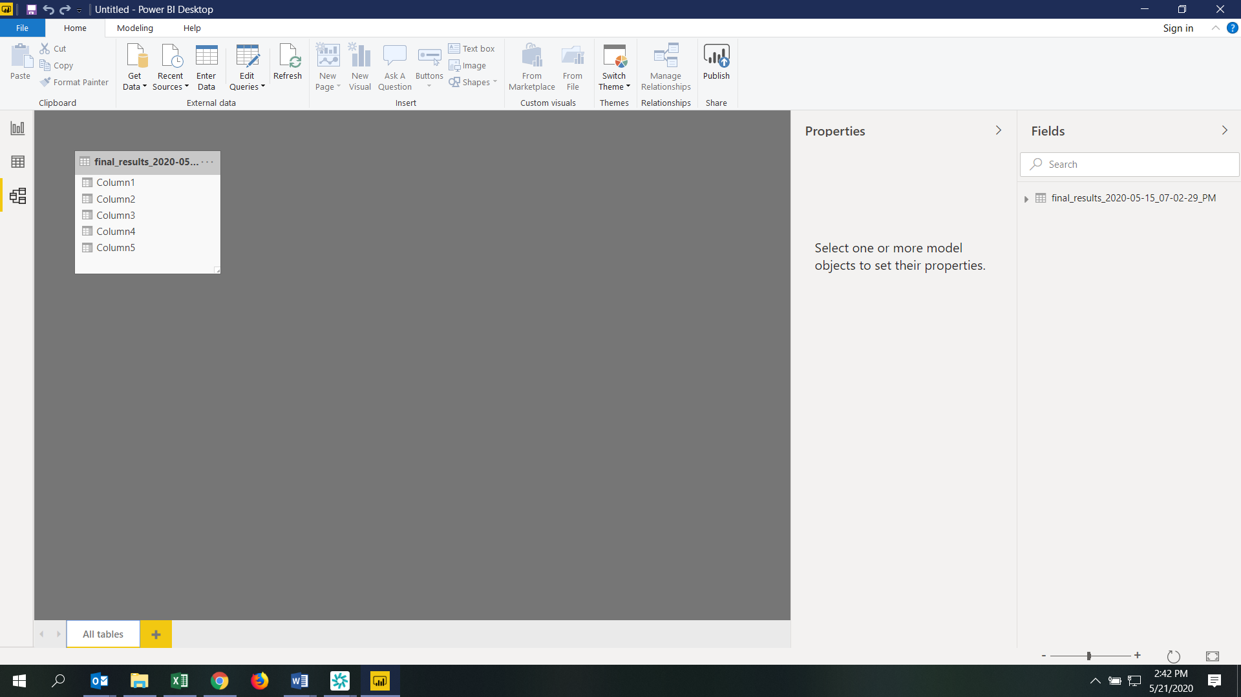
   4. Power Query Editor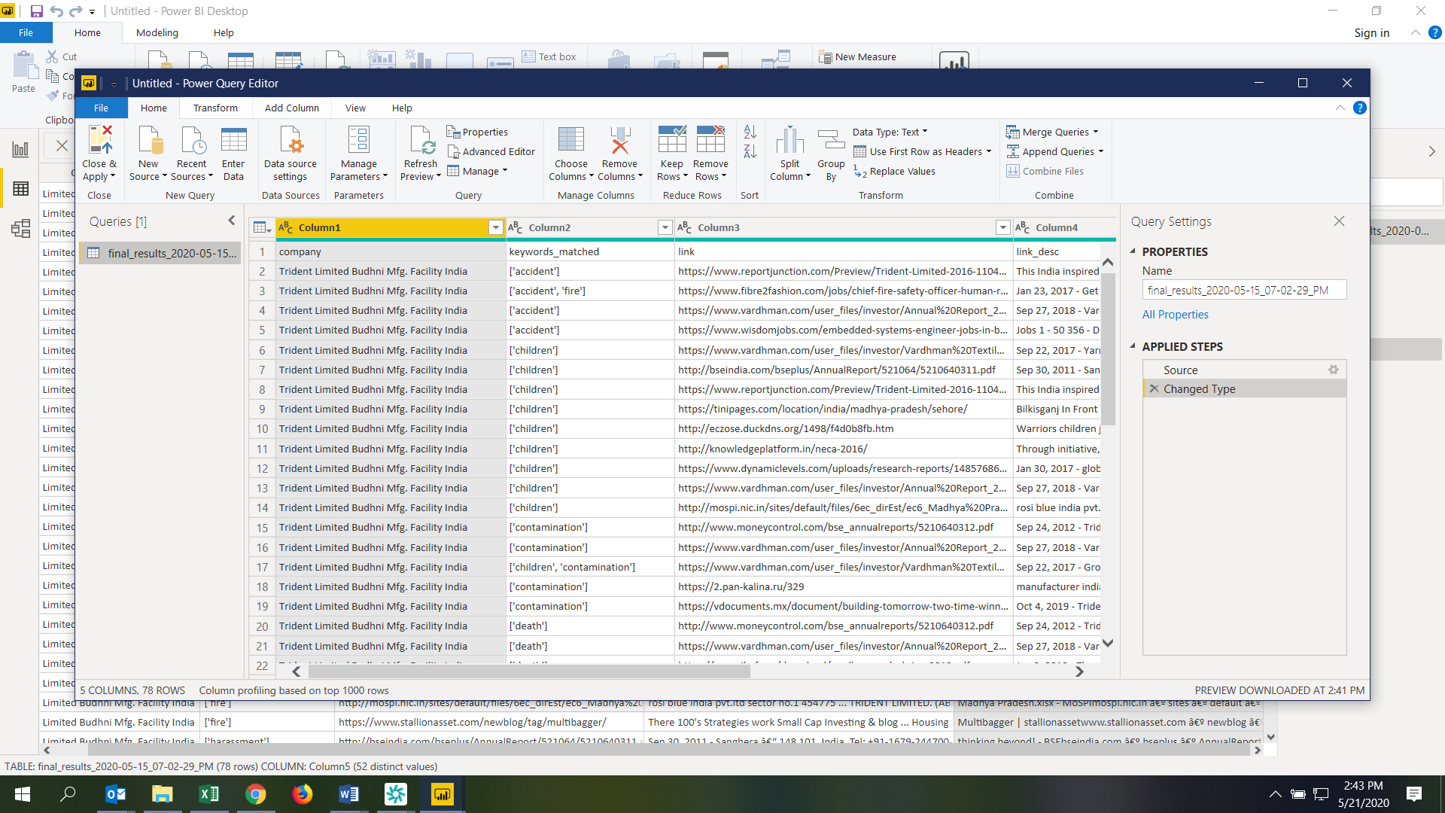
   5. Advance Editor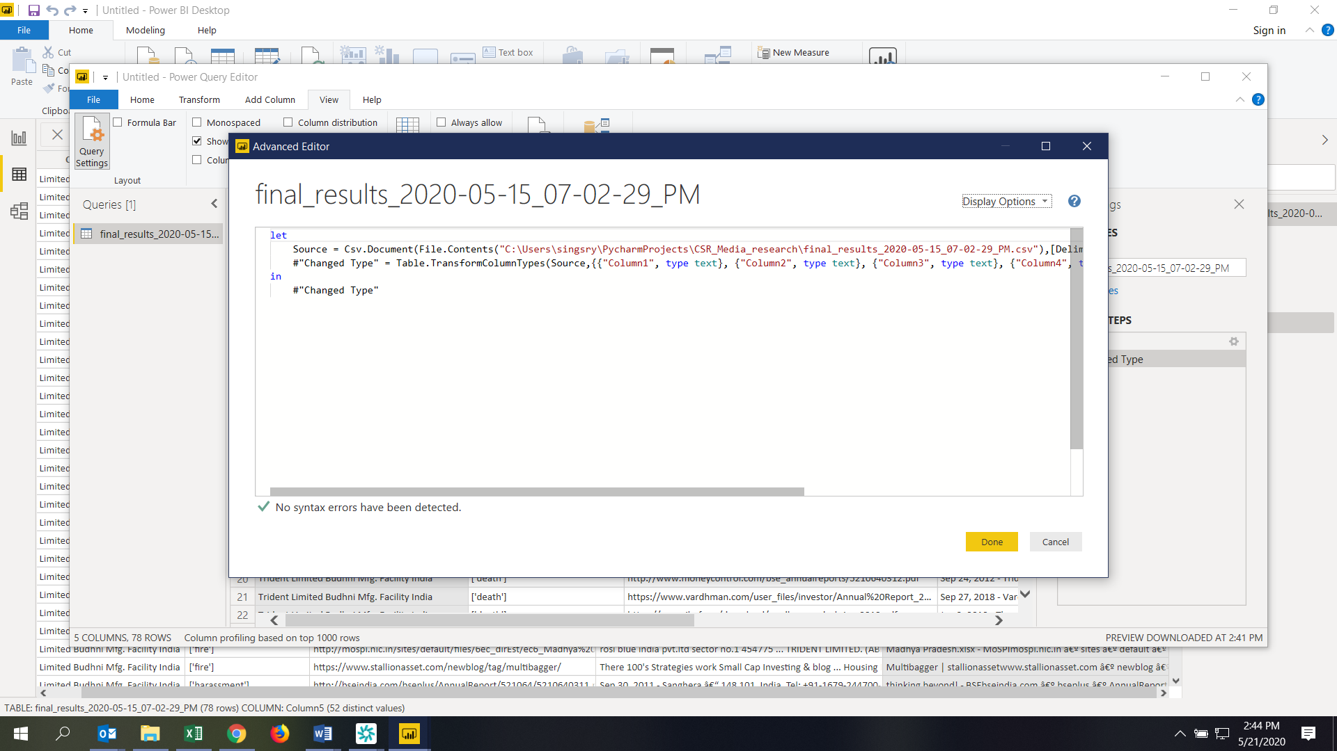
3. Prepare a document with details of the following along with their price
   1. Power BI Desktop
   2. Power BI Pro
   3. Power BI Premium

|  |  |  |
| --- | --- | --- |
|  | Price | Details |
| Power BI Desktop | Free | Power BI Desktop is a BI based software from Microsoft. Power BI Desktop is an application we can install on our local computer that helps connect to, transform, and visualization of data. Most users who work on business intelligence projects use Power BI Desktop to create reports, and then use the Power BI service to share their reports with others |
| Power BI PRO | $9.99 / Monthly per user | Power BI Pro is an individual user license that lets users read and interact with reports and dashboards that others have published to the Power BI service. Users with this license type can share content and collaborate with other Power BI Pro users. |
| Power BI Premium | $4,995  Monthly price per dedicated cloud compute and storage resource with annual subscription | Power BI Premium is a tenant-level Office 365 subscription available in two SKU (Stock-Keeping Unit) families: P SKUs (P1-P5) for embedding and enterprise features, requiring a monthly or yearly commitment, billed monthly, and includes a license to install Power BI Report Server on-premises |